0110552: Changes to Network Edit modules

Objectives Provided

* Create a new package which will contain Norfolk specific procedures. It can be called XNCC_HERM_XSP and should contain the code in procedures gen_herm_xsp and ins_herm_xsp.
* Add a procedure to this package which executes the code from the current nm3replace lines from 635 in the Norfolk@norfolk schema – namely the code below.

|  |
| --- |
| if nm3get.get_ne(p_ne_id_new).ne_nt_type = 'ESU' then           insert into herm_xsp(hxo_ne_id_of, hxo_nwx_x_sect, hxo_start_date,                                hxo_offset, hxo_end_date, hxo_xsp_offset, hxo_herm_dir_flag, hxo_xsp_descr )           select p_ne_id_new, nwx_x_sect, p_effective_date, nwx_offset*nm_cardinality, nm_end_date, nwx_offset, nm_cardinality , nwx_descr    from nm_nw_xsp, nm_elements, nm_members_all    where ne_id = nm_ne_id_in    and   nwx_nsc_sub_class = ne_sub_class    and nm_ne_id_of = p_ne_id    and nm_obj_type = 'SECT'    and nwx_nw_type = 'HERM';  end if; |

* Replaced this code into the nm3replace package and the same code executed in the split and merge functions at a point where the new elements have been created (usually prior to the spatial generation – say line 1260 of split.
* Once this is coded on Norfolk, test using a split of an ESU on exdl16 with a lateral offset and/or comms cabinet and ensure the lateral offset shape is consistent with the new elements.
* Next, there needs to be code to remove a record from the herm_xsp table – this is to be slotted in when an ESU is removed after an undo operation. It is largely a reversal of the code that inserts the data.

Actions carried out

NM3_DYNSEG

PVCS tags added and checked into PVCS.

XNCC_HERM_XSP.GEN_HERM_XSP & XNCC_HERM_XSP.INS_HERM_XSP

New XNCC_HERM_XSP package created and procedures added to it.

I checked to make sure that the old procedures were not referenced anywhere and they are not so no other changes required.

XNCC_HERM_XSP.POPULATE_HERM_XSP

Create XSP_HERM procedure has been added and has 3 parameters for the new ne_id, old ne_id and effective date.

Added to the following modules

|  |  |
| --- | --- |
| Nm3split.Do_Split | Called twice for both of the new ESU. |
| Nm3merge.merge_elements | Called twice to give the new ESU all the attributes of its children. This resulted in a modification of the procedure as calling it twice resulted in a primary key violation this is because there were common combinations in the children. I have added a check to only insert when the value does not already exist. |
| Nm3replace. | Called once for the new ESU. |
| Nm3reclass.reclassify_element | Called once for the new ESU. From what I can tell this is only available in the forms so a refresh of the layer is required for changes to be shown in SM. |

XNCC_HERM_XSP.DELETE_HERM_XSP

Delete XSP_HERM is currently a very simple procedure as all it needs to do is delete the files. It has one parameter (ne_id) to identify the network that needs its XSP_HERM records that need removing.

|  |  |
| --- | --- |
| Nm3undo.unreplace | Added before the deletion of the new element. |
| Nm3undo.unsplit | Called twice to remove data for both new ESU. Called before unspit_datum/unsplit_group called. |
| Nm3undo.unmerge | Added before the deletion of the new element. |

Close/Unclose I do not believe need any changes as this simple end dates and un-end dates network rather than replaces them for new sections of network.

Recalibrate(Shift): This just changes the begin and end MP on the members table.

Recalibrate(Shift): This just changes the length on the elements table.

Unit test guide

|  |  |  |
| --- | --- | --- |
|  | In SM | In forms |
| Replace | Worked as expected. | Worked but shape was only shown after refresh of layer. |
| Unreplace | Worked as expected. | Worked but shape was only shown after refresh of layer. |
| Split | Worked as expected. | Worked but shape was only shown after refresh of layer. |
| Unsplit | Worked as expected. | Worked but shape was only shown after refresh of layer. |
| Merge | Worked as expected. | Worked but shape was only shown after refresh of layer. |
| Unmerge | Worked as expected. | Worked but shape was only shown after refresh of layer. |
| Reclassify | See issue 1 below. | Worked but shape was only shown after refresh of layer. |

The layer needs refreshing if the layer update on edit is set to “I” in the map and all the time when changes are carried out in the form. When I changed this to I all the lateral offsets did not appear offset. I am currently investigating this.

Issues found during unit testing

1. When reclassifying the same asset on the same day I get the following error. This is the constraint in the xsp_herm table.

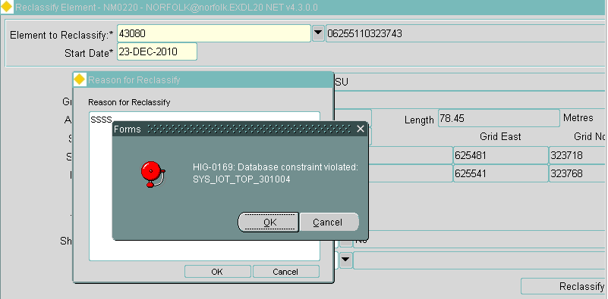

This was fixed by only using non end dated elements in the insert statement.

1. Error attempted closing elements with a layby located on it.

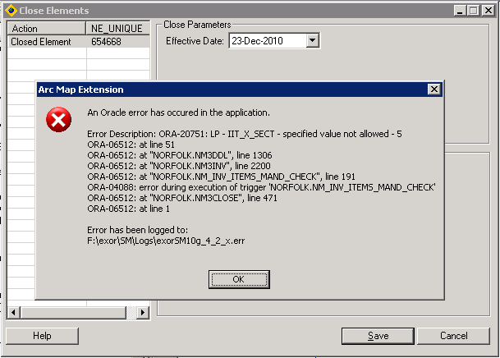

Concerns/Questions

1. The remove metadata script clears out the iit_chr_attrib51 field. If the subclass_update script is then run it will update all subclasses to null. I did this once by accident by going through the process twice. I think the scripts needs slightly modifying to prevent the customers from doing this by accident also.